* **Install React**

**

*npm install -g create-react-app*

* **Create a new React project**

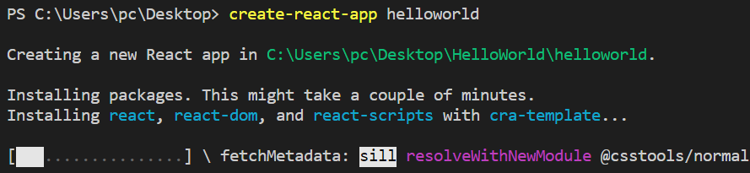 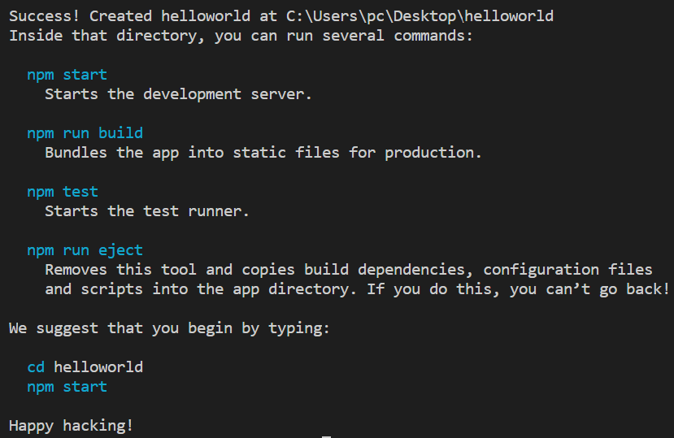

*create-react-app name_project*

* **Run project**

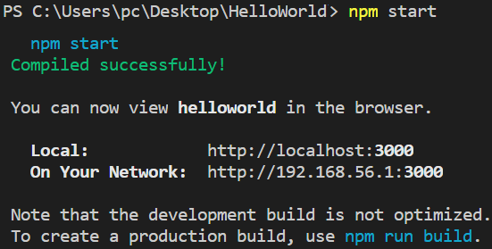

*npm start*

* **Structure project**
  + **node_modules folder**

Chứa library

* + **public folder**

chứa assets

chứa index.html: trong file này có chứa thẻ 

* + **src folder**

Chứa code

* + **package.json**

Chứa config library version, build, start

* + **README.md**

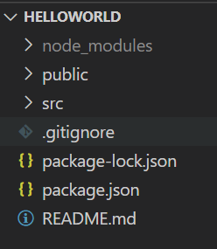

* **Reference**

<https://www.javatpoint.com/react-create-react-app>